# EBU MXF SDK: Phase #1, EBUCore metadata functionality

This document describes the functionality and structure of the EBUCore processing, serialization and extraction part of the EBU MXF SDK. It also describes how to use the EBUCore functions in derivative projects.

## Functionality

The EBU MXF SDK offers functionality for processing EBUCore metadata, and in particular, dealing with the inclusion and extraction of EBUCore metadata in Material Exchange Format (MXF) audiovisual essence container files.

### Concepts of EBUCore Processing

This section describes the EBUCore processing functionality of the SDK (illustrated in Section ➊ in Figure 1). The SDK can read and write two representations of EBUCore; the XML variant is read from and written to XML documents that conform to the EBUCore XML schema[1], the MXF variant is read and written to KLV packets, the native encoding of information units in MXF files, that conform to the Class 13 SMPTE metadata dictionary register for EBUCore. For both XML and MXF representations, the EBUCore metadata is read (or written to) an in-memory representation (i.e., an instantiated object model) first and then translated to the other representation through a bi-directional mapping which translates peculiarities between both sides.

The source code that defines the object model for both representations has been generated automatically. It should be again generated when modifications are done the source definitions, either to the EBUCore XML schema (using the Codesynthesis XSD schema compiler), or the MXF-KLV metadata dictionary (using the gen_ebucore_classes tool and dictionary translator scripts, dictconvert.groovy and declarereferences.groovy).

#### Serialization of EBUCore metadata as KLV packets

Concerning the serialization of KLV EBUCore packets into MXF files, the SDK can function in one of two modes, as part of the wrapping process of raw essence into a new MXF file, and as part of the extension process of an existing MXF file.

Firstly, and illustrated in Section ➋ in Figure 1, the SDK can operate in a mode where a new MXF file is constructed from a number of essence tracks (delivered in separate files) and the EBUCore KLV packets are mixed in with the newly constructed metadata (incl., track structure and essence characteristics) of the MXF file. In this case, the metadata is written as part of the header partition, which is marked closed and complete. There is no need for metadata to be written to any of the body or footer partitions.

The **raw2bmx** example program in ebu-bmx/apps/raw2bmx demonstrates the use of this first mode of operation. Along with the parsing of raw essence and inclusion of its structural metadata in a newly written MXF file, the EBUCore metadata is processed from an XML document, hooked onto the MXF file metadata model, and then written to the file along with the other KLV packets in the MXF container.

In the second mode of operation, the SDK writes EBUCore metadata into an existing MXF file, the path depicted in Section ➌ in Figure 1. This mode requires more complex application logic, as the existing file must 1) be modified as efficiently as possible, and 2) the existing metadata must be modified in such a way as to remain fully compliant with the MXF file format specification.  
MXF files may carry multiple instances of the file’s metadata (each new file partition can contain an updated set of metadata). This way, streaming and growing file scenarios can be supported in which increasingly accurate metadata is continuously inserted as the file being is extended, resulting in an MXF file that contains the most complete metadata in its footer partition. Partitions marked as open and incomplete can instruct MXF interpreters to ignore early sets of metadata and only consider a final closed and complete metadata set as the definitive MXF file structure description.  
Unless explicitly instructed otherwise, the SDK uses this mechanism to append the updated metadata in the footer partition of the MXF file. This involves a rewrite of only the footer partition, which is requires only limited writing operations since footer partitions contain no essence. Most of the header and (bulky) body partitions remain unchanged, except for an update of the small partition header KLV pack to signal an – as of now – open and incomplete metadata set. Note that, when selecting the metadata to extend, the SDK also interprets partition flags to select only the finalized metadata for extension with EBUCore elements.

Considering the complexity of the MXF file format specification, it is not unlikely that certain implementations of MXF interpreters will lack support for selection of metadata beyond the header partition, and will expect this partition to contain only a single complete metadata set. To support these systems, the SDK can be overridden to write the EBUCore metadata to the header partition, at the expense of a byte shift operation across the remainder of the MXF file.

The **ebu2mxf** example program in ebu-bmx/apps/ebu2mxf demonstrates the use of this second mode of operation. An existing MXF file is opened, and the EBUCore metadata is appended to its most appropriated (closed and complete metadata where available) set of metadata. This mode uses an identical EBUCore processing path as in the first operation mode, but only attempts to modify only the file metadata without rewriting its essence.

To use the SDK in this mode, use one of the EBUCore::EmbedEBUCoreMetadata() functions that are documented in the Doxygen documentation.

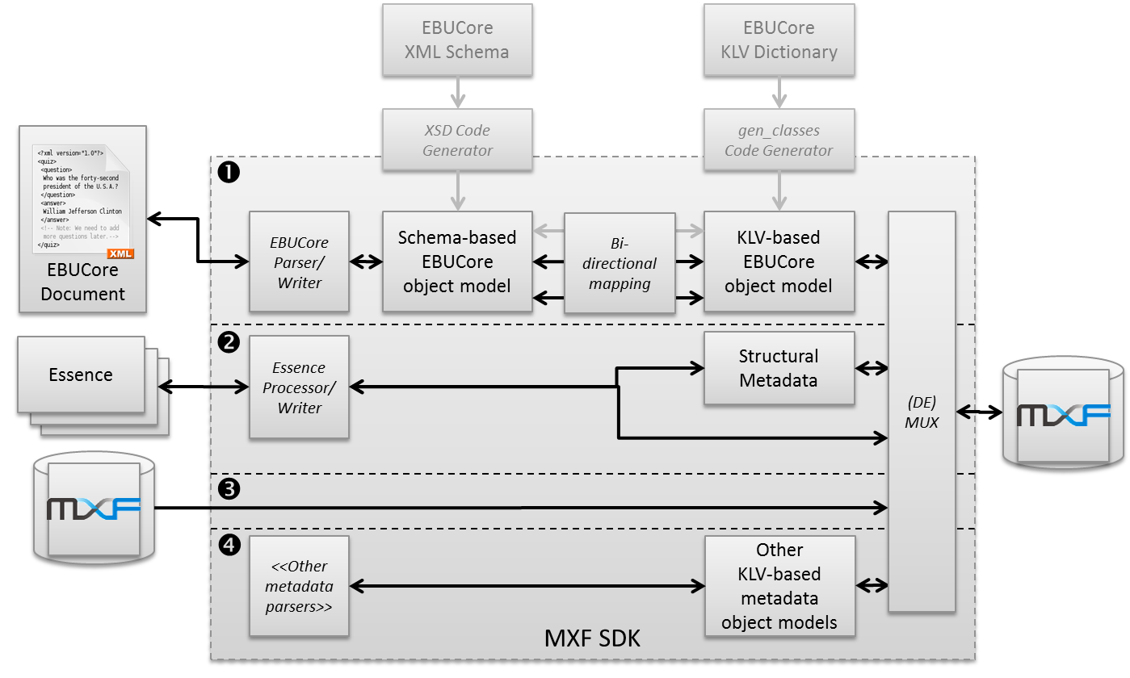

Figure 1: EBU SDK block diagram.

#### Extraction of EBUCore metadata from MXF files

The EBU MXF SDK also operates in the reverse direction of the serialization functionality explained before. EBUCore metadata can be extracted from MXF KLV packets and translated to the XML representation, by following the reverse path of Section ➊ in Figure 1. Just as in the serialization direction, the EBUCore metadata is extracted from the most appropriate header metadata (closed and complete where available). The EBUCore metadata is then located by searching through the structural metadata and MXF timeline model, as described in the next section.

The **mxf2ebu** example program in ebu-bmx/apps/mxf2ebu demonstrates the use of EBUCore metadata extraction. An existing MXF file is opened, and the EBUCore metadata is read from its metadata.

To use the SDK for EBUCore extraction, use one of the EBUCore::ExtractEBUCoreMetadata() functions that are documented in the Doxygen documentation.

#### EBUCore and the MXF Timeline

The EBUCore metadata is inserted into the MXF metadata in such a way that in properly interacts with the timeline model of the MXF file format, as illustrated in Figure 2. Alongside the timeline tracks that describe the essence, a Descriptive Metadata static track is inserted, which contains a reference to the entry point of the EBUCore metadata: an *ebucoreMainFramework* instance. *Part* definitions described in more complex EBUCore documents are also properly modelled on the MXF timeline by using a Descriptive Metadata event track on which temporal segments with a reference to an *ebucorePartFramework* object instance are assigned for each of the *Part* elements.



Figure : EBUCore metadata and the MXF timeline.

## SDK Structure and Dependencies

In this section, a short description of given of the individual components of the SDK, and the limited set of software components it depends on, as shown in Figure 3. Basic MXF manipulation and parsing functionality has been inherited from the BBC’s libMXF (the C library) and libMXF++ (a C++ wrapper library of the libMXF functions). libMXF++ (and as such also libMXF) are used by the BMX higher-level library for MXF manipulations for specific Application Specifications (e.g., AS-02, AS-11, …). This BMX library is in turn also used by the EBU SDK code, along with libMXF++. At the moment, as separate code repository is used for libMXF, libMXF++ and BMX+EBU SDK.



Figure : Dependencies in the EBU SDK.

The SDK depends on the following software components.

* uriparser: a library for parsing URIs;
* Apache Xerces-C++: a library for processing XML documents and XML schema validation;
* Codesynthesis XSD: a library for generating XML schema-based parsers and serializers.

For this version of the SDK, programs are use the SDK statically link to the functionality of the SDK, no explicit provisions have been made yet to produce a dynamically linkable library.

## EBU SDK Source Code

The source code for the SDK consists of three repositories, cloned from the BMX and related code by BBC. It is publicly available at the following locations:

|  |  |
| --- | --- |
| <http://sourceforge.net/p/bmxlib/libmxf/> | This is the original BBC repository, as no changes have been made here yet. Contains the base MXF functionality written in C, including code for reading KLV units, partitions, metadata, … |
| <https://github.com/Limecraft/ebu-libmxfpp> | C++ wrappers for the libmxf library, with a number of extensions for the EBU SDK. |
| <https://github.com/Limecraft/ebu-bmx> | Contains the SDK-specific functionality is here, along with the original high-level BMX libraries by BBC. |

### Building the source code on UNIX-type systems

The SDK inherits the build system from the BBC BMX libraries, and uses a sequence of automatically generated configuration files that automate the build process, incl. tools such as GNU automake and GNU autoconf.

The code depends on a number of software frameworks that must be present before building.

|  |  |
| --- | --- |
| uriparser | Clone the publicly available repository into the directory where the three EBU SDK repositories have been checked out, from the following location:  git://uriparser.git.sourceforge.net/gitroot/uriparser/uriparser  Make sure the repository is checked out into a directory named “uriparser”. Then use the uriparser build instructions to make and install the library. |
| Codesynthesis XSD (version 3.3.0) | Depending on the system specifics, this component could be present in the system package/software management repository and can be installed from there. Otherwise binary packages and source archives are available at: <http://www.codesynthesis.com>.  Note: The EBU SDK requires only header files from the XSD component. No binary libraries need to be linked with SDK-produced software. |
| Apache Xerces-C++ (version 3.1.1) | Depending on the system specifics, this component is likely to be present in the system package/software management repository and can be installed from there. Otherwise binary packages and source archives are available at: <http://xerces.apache.org/xerces-c/>. |

The following commands build the SDK, and install the code it provides to a system-wide accessible location for other software to use.

Apart from the dependencies, this document assumes that all code repositories are checked out into a common parent directory from which the following commands should be executed.

cd libmxf  
./gen_scm_version.sh  
./autogen.sh  
./configure  
make  
make install

cd libmxfpp  
./gen_scm_version.sh  
./autogen.sh  
./configure  
make  
make install

cd ebu-bmx  
./gen_scm_version.sh  
./autogen.sh  
./configure  
make  
make install

### Building the source code on Windows systems

The source code includes Solution and Project files for the Microsoft Visual Studio 2010 development environment. From these project files, available in each repository’s /msvc_build/vs10 directory, the project can be built directly, provided that the location of the include directories for the dependencies are updated or added in the Visual Studio projects.

The code depends on a number of software frameworks that must be present before building.

|  |  |
| --- | --- |
| uriparser | Clone the publicly available repository into the directory where the three EBU SDK repositories have been checked out, from the following location:  git://uriparser.git.sourceforge.net/gitroot/uriparser/uriparser  Make sure the repository is checked out into a directory named “uriparser”. Then use the uriparser build instructions to make and install the library, thereby possibly upgrading the solution and project files to a newer Visual Studio format. |
| Codesynthesis XSD (version 3.3.0) | The binary archive of this component can be found in the ebu-bmx repository: \dependencies\xsd-3.3.0-i686-windows.zip. This archive must be extracted, and references (in include files and library directories) from the EBU SDK must be updated to the proper location.  Note: The EBU SDK requires only header files from the XSD component. No binary libraries need to be linked with SDK-produced software. |
| Apache Xerces-C++ (version 3.1.1) | The binary archive of this component can be found in the ebu-bmx repository: \dependencies\ xerces-c-3.1.1-x86-windows-vc-10.0.zip. This archive must be extracted, and references (in include files and library directories) from the EBU SDK must be updated to the proper location. |

1. The EBU SDK employs the EBU_CORE_20110915.xsd version of the EBUCore XML schema.